Shambhavi Kumar

19BIT115

ACD LAB EXPERIMENTS

Contents

EXPERIMENT 1 3

AIM 3

TOOLS REQUIRED 3

THEORY 3

CIRCUIT DIAGRAM 4

OBSERVATION TABLE 4

GRAPH 5

RESULT 5

Questions 5

EXPERIMENT 2 6

AIM 6

TOOL REQUIRED 6

THEORY 6

CIRCUIT 6

OBSERVATION 7

GRAPH 8

RESULT 10

EXPERIMENT 3 10

AIM 10

TOOL REQUIRED 10

THEORY 10

CIRCUIT 10

OBSERVATION TABLE 11

GRAPH 12

RESULT 12

QUESTIONS 12

EXPERIMENT 4 AND 5(B) 12

AIM 12

TOOL REQUIRED 13

THEORY 13

CIRCUIT 13

OBSERVATION 14

GRAPH 14

RESULT 14

EXPERIMENT 5(A) 15

AIM 15

TOOL REQUIRED 15

THEORY 15

CIRCUIT 15

OBSERVATION TABLE 15

GRAPH 16

RESULT 16

QUESTIONS 17

EXPERIMENT 7 17

AIM 17

MATERIALS REQUIRED 17

THEORY 17

CIRCUIT 17

OBSERVATION 18

GRAPH 19

QUESTIONS 19

EXPERIMENT 10 19

AIM 19

MATERIAL REQUIRED 19

THEORY 20

CIRCUIT 21

QUESTIONS 22

EXPERIMENT 12 22

AIM 22

APPARATUS REQUIRED 22

THEORY 22

CIRCUIT 23

RESULT 23

EXPERIMENT 13 23

AIM 23

MATERIAL REQUIRED 23

THEORY 23

CIRCUIT 24

RESULT 24

# EXPERIMENT 1

# AIM

To study input and output characteristic of common emitter configuration

# TOOLS REQUIRED

MULTISIM

# THEORY

A. Input Characteristics: ‐ It is the curve between input current IB and input voltage VBE constant collector emitter voltage VCE. The input characteristic resembles a forward biased diode curve. After cut in voltage the IB increases rapidly with small increase in VBE. It means that dynamic input resistance is small in CE configuration. It is the ratio of change in VBE to the resulting change in base current at constant collector emitter voltage. It is given by ΔVBE / ΔIB

B. Output Characteristics: ‐ This characteristic shows relation between collector current IC and collector voltage for various values of base current. The change in collector emitter voltage causes small change in the collector current for the constant base current, which defines the dynamic resistance and is given as ΔVCE / ΔIC at constant IB. The output characteristic of common emitter configuration consists of three regions: Active, Saturation and Cut‐off.

Active region: In this region base‐emitter junction is forward biased and base‐collector junction is reversed biased. The curves are approximately horizontal in this region.

Saturation region: In this region both the junctions are forward biased.

Cut‐off: In this region, both the junctions are reverse biased. When the base current is made equal to zero, the collector current is reverse leakage current ICEO. The region below IB = 0 is the called the cutoff region.

# CIRCUIT DIAGRAM

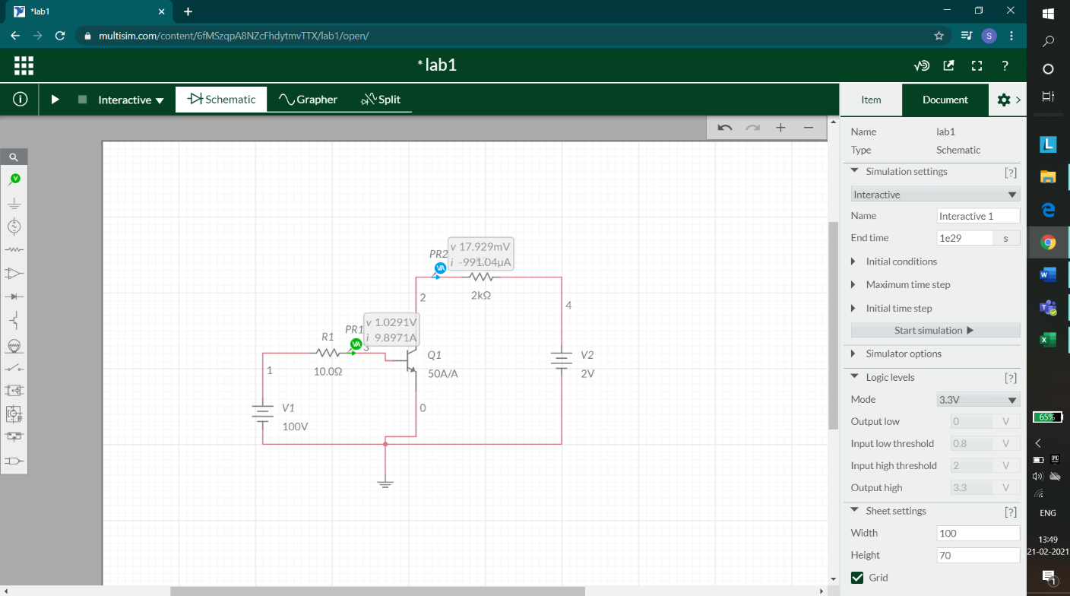

OBSERVATION TABLE

# GRAPH

INPUT CHARACTERISTICS

OUTPUT CHARACTERISTIC

# RESULT

Ib grows exponentially on keeping Vce constant and varying the Vbe.

# Questions

1. What is the function of base region of a transistor? Why is this region made thin and lightly doped?

2. What is the voltage across the collector to emitter terminal when the transistor is in (i) saturation (ii) cut-off (iii) active region?

3. Describe, based on your observations, the I-V curves of npn transistor. At approximately what collector-emitter voltage (VCE) does the transition from saturation to active region occur?

4. Describe the necessary conditions operation in the active region in terms of VBE and VCE.

5. What is base width modulation?

# EXPERIMENT 2

## AIM

To study transfer and output characteristics of FET and MOSFET

## TOOL REQUIRED

Multisim

## THEORY

1. FET

The Field Effect Transistor or Simply FET uses the voltage that is applied to their input terminal, called the Gate to control the current flowing through them resulting in the output current being proportional to the input voltage, the Gates to source junction of the FET is always reversed biased. As their operation relies on an electric field (hence the name field effect) generated by the input Gate voltage, this then makes the Field Effect Transistor a “VOLTAGE” operated device. The Field Effect Transistor is a three terminal unipolar semiconductor device that has very similar characteristics to those of their Bipolar Transistor counterpart’s i.e., high efficiency, instant operation, robust and cheap and can be used in most electronic circuit applications to replace their equivalent bipolar junction transistors (BJT).

1. MOSFET

The MOSFET is actually a four-terminal device, whose substrate, or body terminal must be always held at one of the extreme voltages in the circuit, either the most positive for the PMOS or the most negative for the NMOS. One unique property of the MOSFET is that the gate draws no measurable current.

## CIRCUIT

1. FET

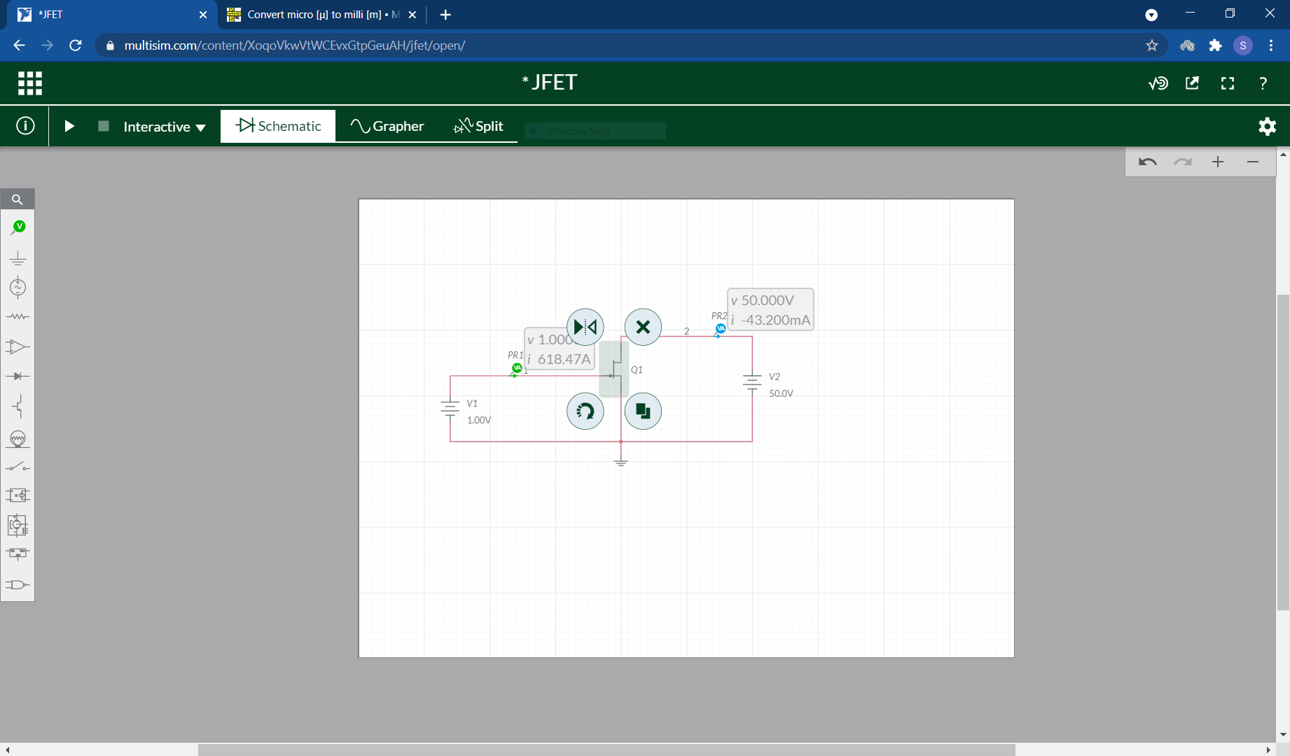

1. MOSFET

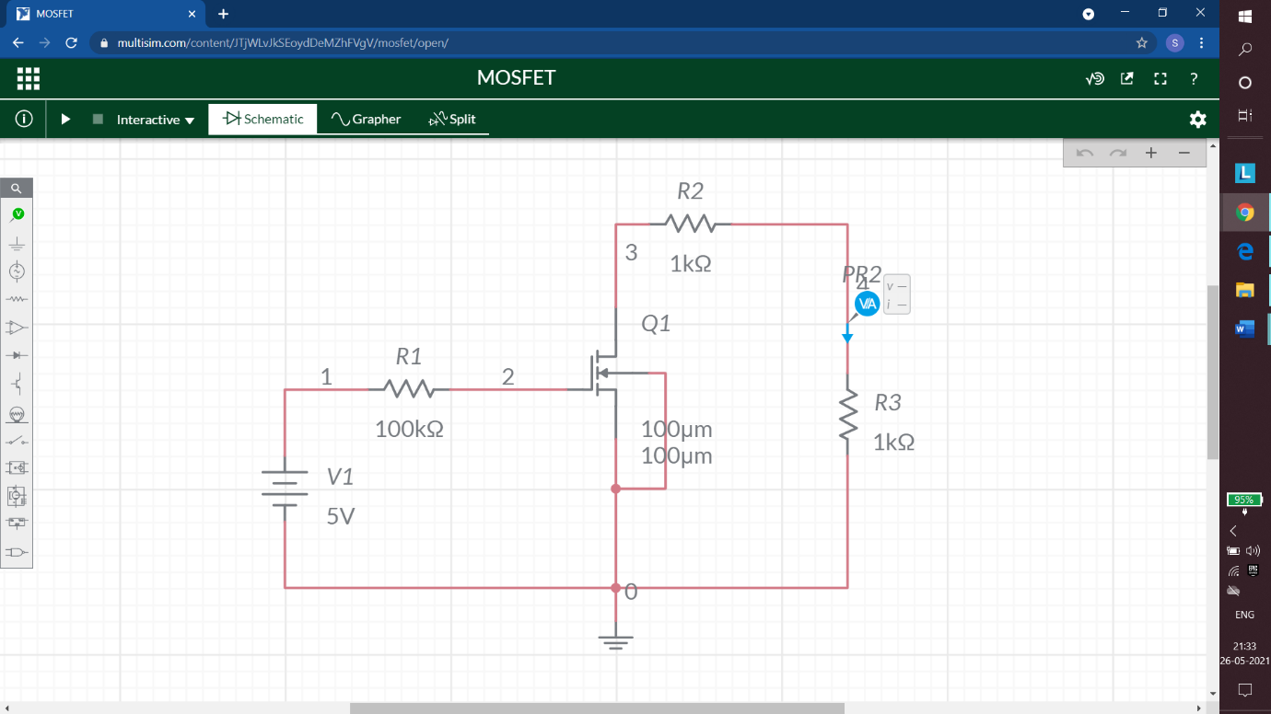

## OBSERVATION

1. FET



1. MOSFET

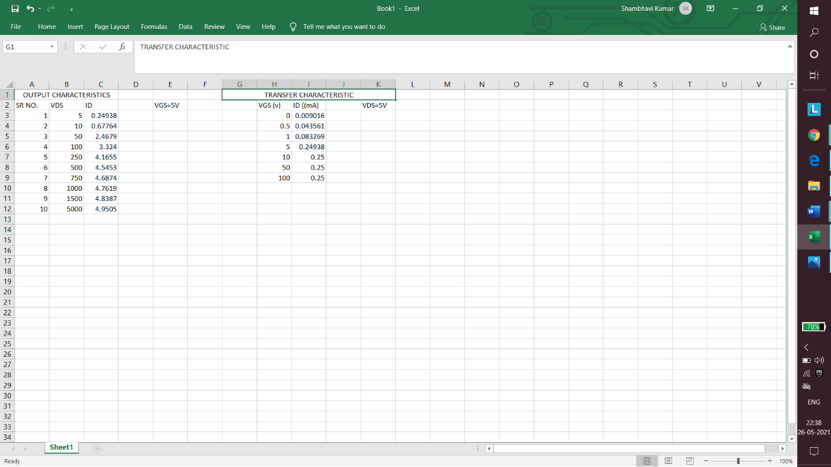

## GRAPH

1. FET
2. MOSFET

## RESULT

The frequency response almost appears to be linear in multisim.

# EXPERIMENT 3

# AIM

1. To find frequency response of CE amplifier

TOOL REQUIRED –

Multisim

# THEORY

Voltage amplifiers come under small signal amplifiers. The shift is small, amplifiers are referred to as small signal amplifiers. The gain of an ideal amplifier should remain the same for any frequency of the input signal. Therefore, the frequency response curve becomes a straight line parallel to the frequency axis.

# CIRCUIT

a)

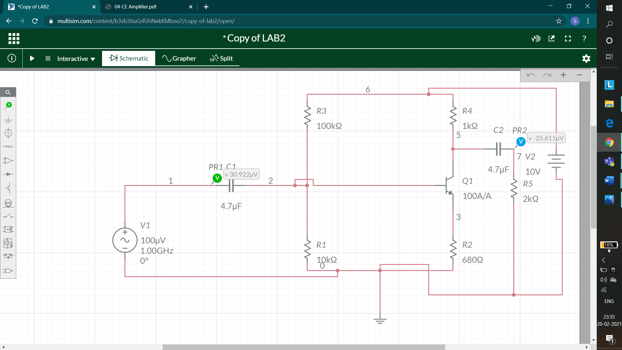

# OBSERVATION TABLE

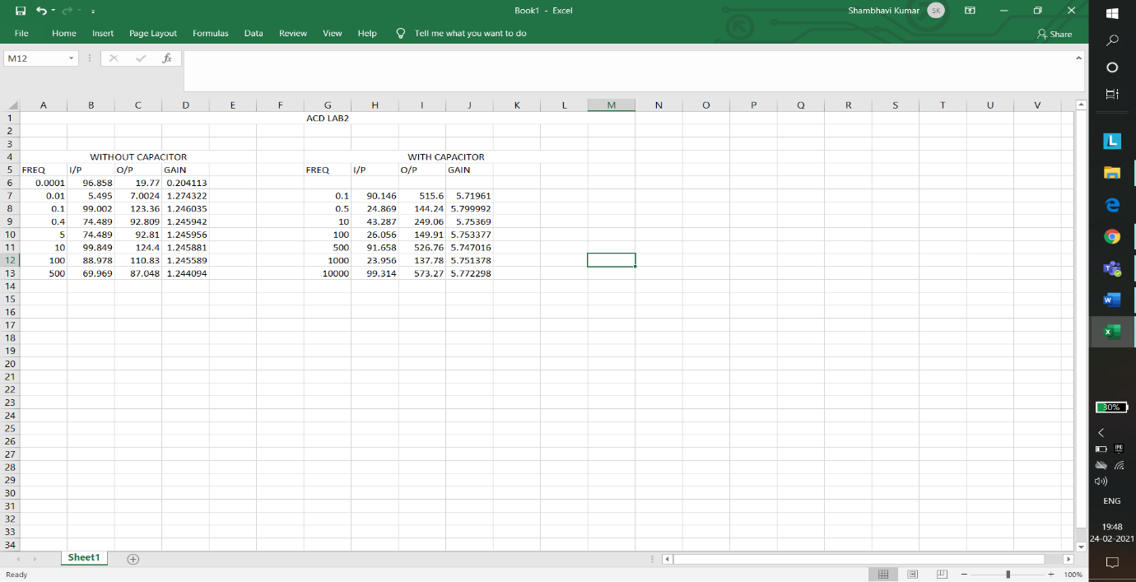

# GRAPH

a)

# RESULT

Frequency response and graph is demonstrated using graph of amplifier with and without feedback.

# QUESTIONS

1. Define β.

2. Explain in detail procedure for measuring β.

3. Using the values of β, determine the value of α.

4. What are the differences, if any in determining the current gain of NPN and PNP transistors?

5. In the circuit, what should be the effect of reversing the polarity of VBB? 6. What is meant by bias stabilization? Why it is used?

7. What is the phase relationship between the input and output signals of CE amplifier?

# EXPERIMENT 4 AND 5(B)

## AIM

To obtain frequency response of RC coupled amplifier

## TOOL REQUIRED

MULTISIM

## THEORY

The experiment performed here is consists of a two-stage RC coupled amplifier. This is very efficient in terms of gain. The output of the first stage is coupled to the second stage as input through the capacitor. The capacitor is also known for blocking the DC signals and providing the smoothing effect to the signals obtained at the output.

As the gain obtained at the two stages will be different this gain values obtained are plotted on the curve with the frequency values. The final gain will be calculated with the product of the individual gains obtained at each stage. The curve obtained from this is known as the frequency response of the amplifier.

## CIRCUIT

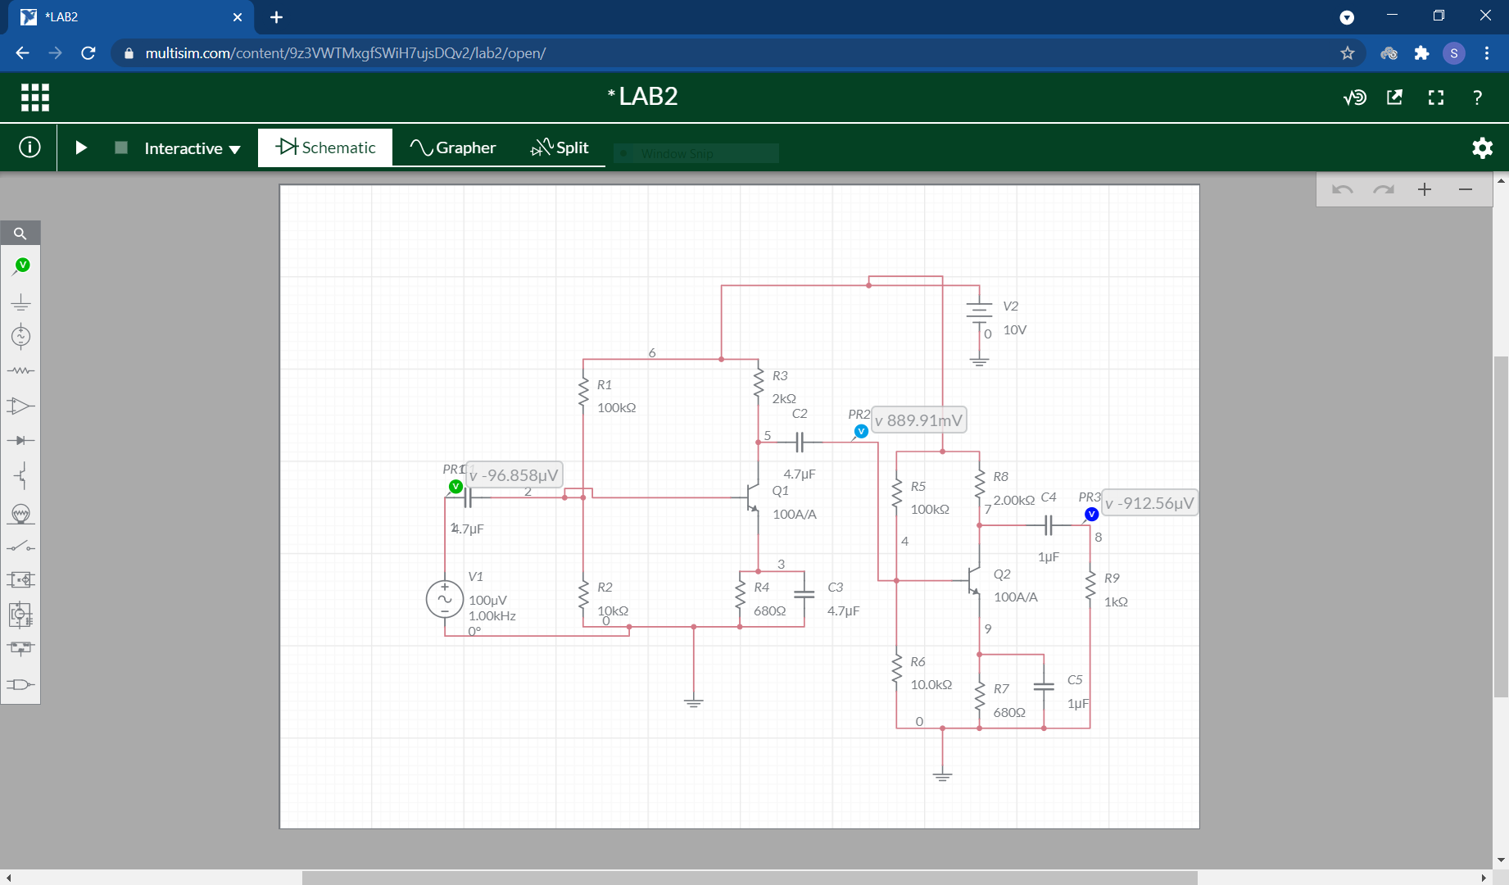

## OBSERVATION



## GRAPH

## RESULT

The voltage gain of the amplifier increases with the frequency, f and attains a maximum value. The maximum value of the gain remains constant over a certain frequency range and afterwards the gain starts decreasing with the increase of the frequency.

# EXPERIMENT 5(A)

# AIM

1. To study effect of bypass Capacitor

TOOL REQUIRED - Multisim

# THEORY

Voltage amplifiers come under small signal amplifiers. The shift is small, amplifiers are referred to as small signal amplifiers. The gain of an ideal amplifier should remain the same for any frequency of the input signal. Therefore, the frequency response curve becomes a straight line parallel to the frequency axis.

# CIRCUIT

# OBSERVATION TABLE



# GRAPH

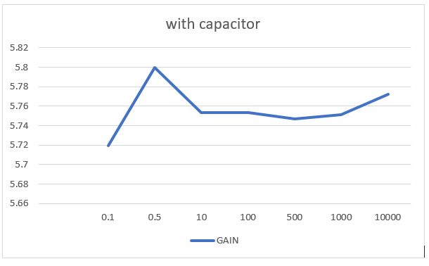

# RESULT

Frequency response and graph is demonstrated using graph of amplifier with and without feedback.

# QUESTIONS

1. Define β.

2. Explain in detail procedure for measuring β.

3. Using the values of β, determine the value of α.

4. What are the differences, if any in determining the current gain of NPN and PNP transistors?

5. In the circuit, what should be the effect of reversing the polarity of VBB? 6. What is meant by bias stabilization? Why it is used?

7. What is the phase relationship between the input and output signals of CE amplifier?

# EXPERIMENT 7

## AIM

To design a non-inverting and inverting amplifier

## MATERIALS REQUIRED

Multisim Software

## THEORY

The non-inverting amplifier configuration is one of the most popular and widely used forms of operational amplifier circuit and it is used in many electronic devices. The op amp non-inverting amplifier circuit provides a high input impedance along with all the advantages gained from using an operational amplifier. Although the basic non-inverting op amp circuit requires the same number electronic components as its inverting counterpart, it finds uses in applications where the high input impedance is of importance.

An inverting amplifier using opamp is a type of amplifier using opamp where the output waveform will be phase opposite to the input waveform. The input waveform will be amplifier by the factor Av (voltage gain of the amplifier) in magnitude and its phase will be inverted. In the inverting amplifier circuit the signal to be amplified is applied to the inverting input of the opamp through the input resistance R1. Rf is the feedback resistor. Rf and Rin together determine the gain of the amplifier. Inverting operational amplifier gain can be expressed using the equation Av = – Rf/R1. Negative sign implies that the output signal is negated.

## CIRCUIT

1. NON-INVERTING AMPLIFIER

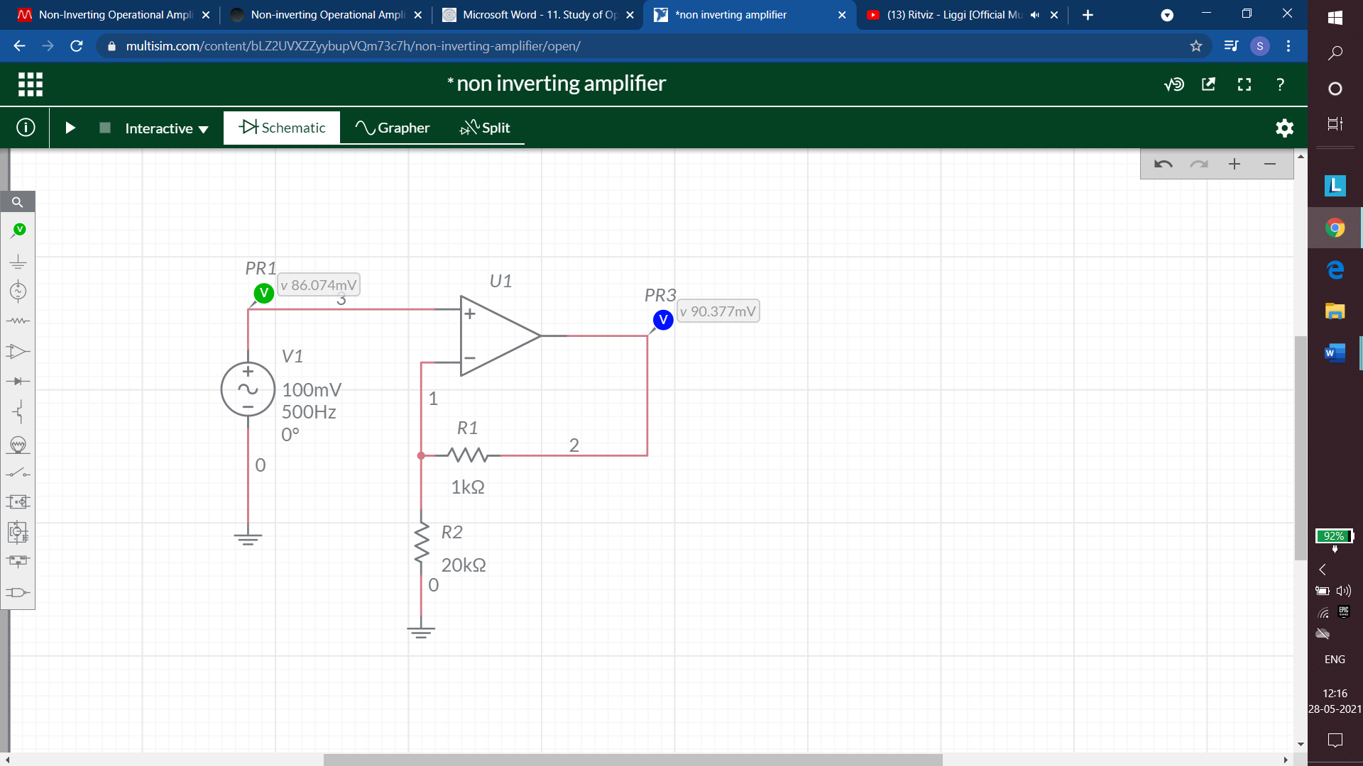

1. INVERTING AMPLIFIER

## OBSERVATION

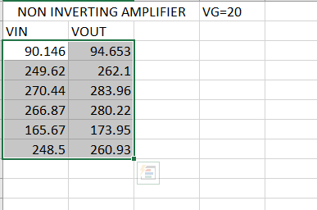

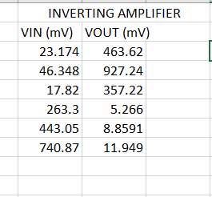

## GRAPH

## QUESTIONS

1. Define an integrated circuit and classify them.

2. What is an op-amp and what are its types?

3. How to define the symbol of op-amp?

# EXPERIMENT 10

## AIM

To design a Astable, Bistable and a monostable multivibrator 555IC timer

## MATERIAL REQUIRED

Multisim software

## THEORY

1. MONOSTABLE VIBRATOR

The operation and output of the **555 timer monostable** is exactly the same as that for the transistorised one we look at previously in the Monostable Multivibrators tutorial. The difference this time is that the two transistors have been replaced by the 555 timer device.

1. ASTABLE MULTIVIBRATOR

Regenerative switching circuits such as Astable Multivibrators are the most commonly used type of relaxation oscillator because not only are they simple, reliable and ease of construction they also produce a constant square wave output waveform.

Unlike the Monostable Multivibrator or the Bistable Multivibrator we looked at in the previous tutorials that require an “external” trigger pulse for their operation, the Astable Multivibrator has automatic built in triggering which switches it continuously between its two unstable states both set and reset.

The Astable Multivibrator is another type of cross-coupled transistor switching circuit that has NO stable output states as it changes from one state to the other all the time. The astable circuit consists of two switching transistors, a cross-coupled feedback network, and two time delay capacitors which allows oscillation between the two states with no external triggering to produce the change in state.

1. BISTABLE VIBRATOR

The **555 Bistable** is one of the simplest circuits we can build using the 555 timer oscillator chip. This bistable configuration does not use any RC timing network to produce an output waveform so no equations are required to calculate the time period of the circuit. The switching of the output waveform is achieved by controlling the trigger and reset inputs of the 555 timer which are held “HIGH” by the two pull-up resistors, R1 and R2. By taking the trigger input (pin 2) “LOW”, switch in set position, changes the output state into the “HIGH” state and by taking the reset input (pin 4) “LOW”, switch in reset position, changes the output into the “LOW” state.

This 555 timer circuit will remain in either state indefinitely and is therefore bistable. Then the Bistable 555 timer is stable in both states, “HIGH” and “LOW”. The threshold input (pin 6) is connected to ground to ensure that it cannot reset the bistable circuit as it would in a normal timing application.

## CIRCUIT

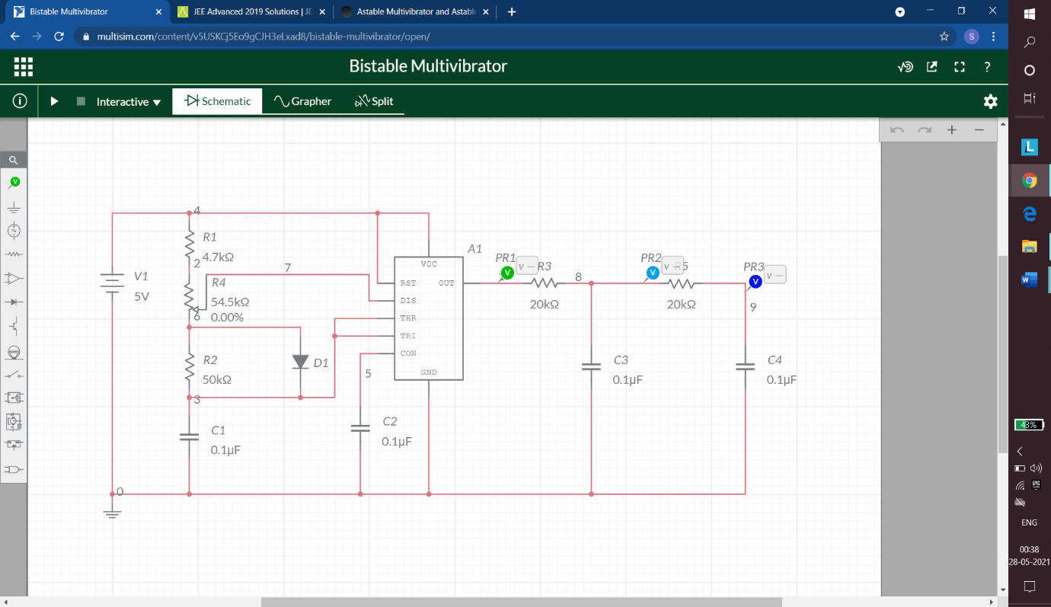

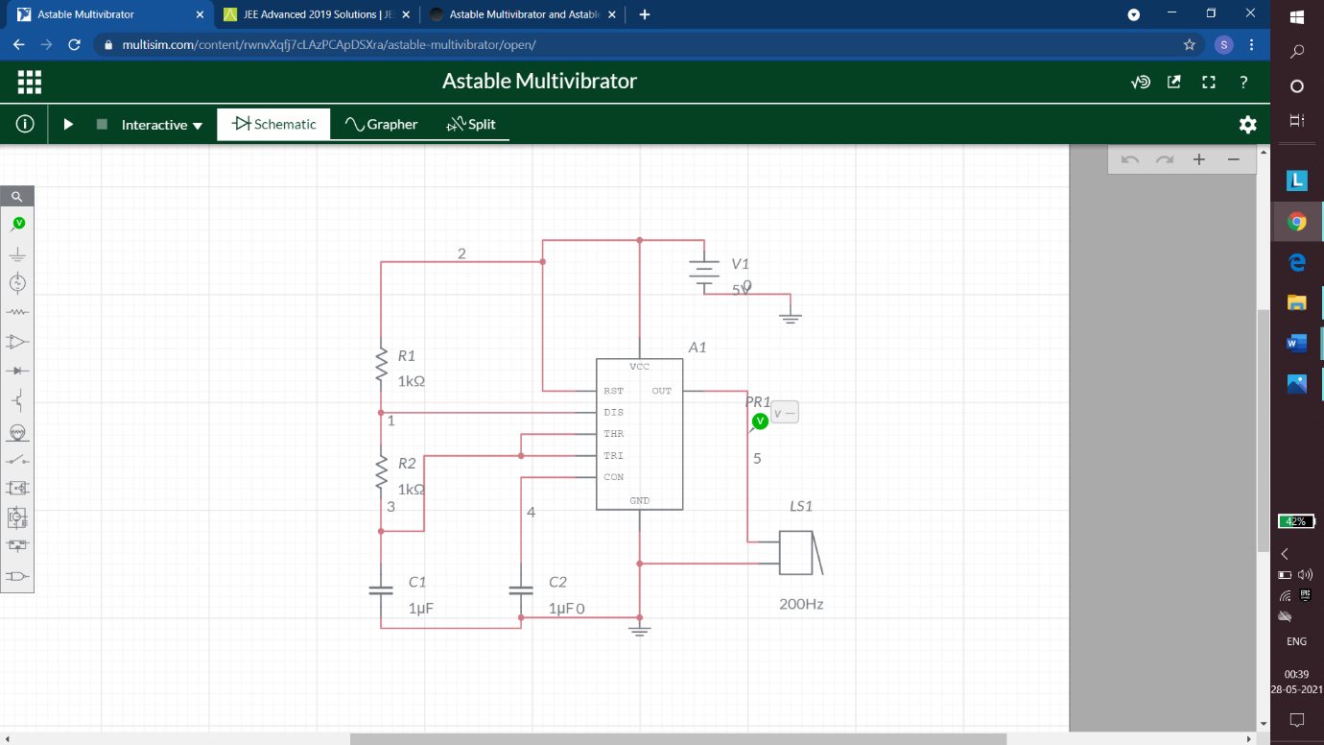

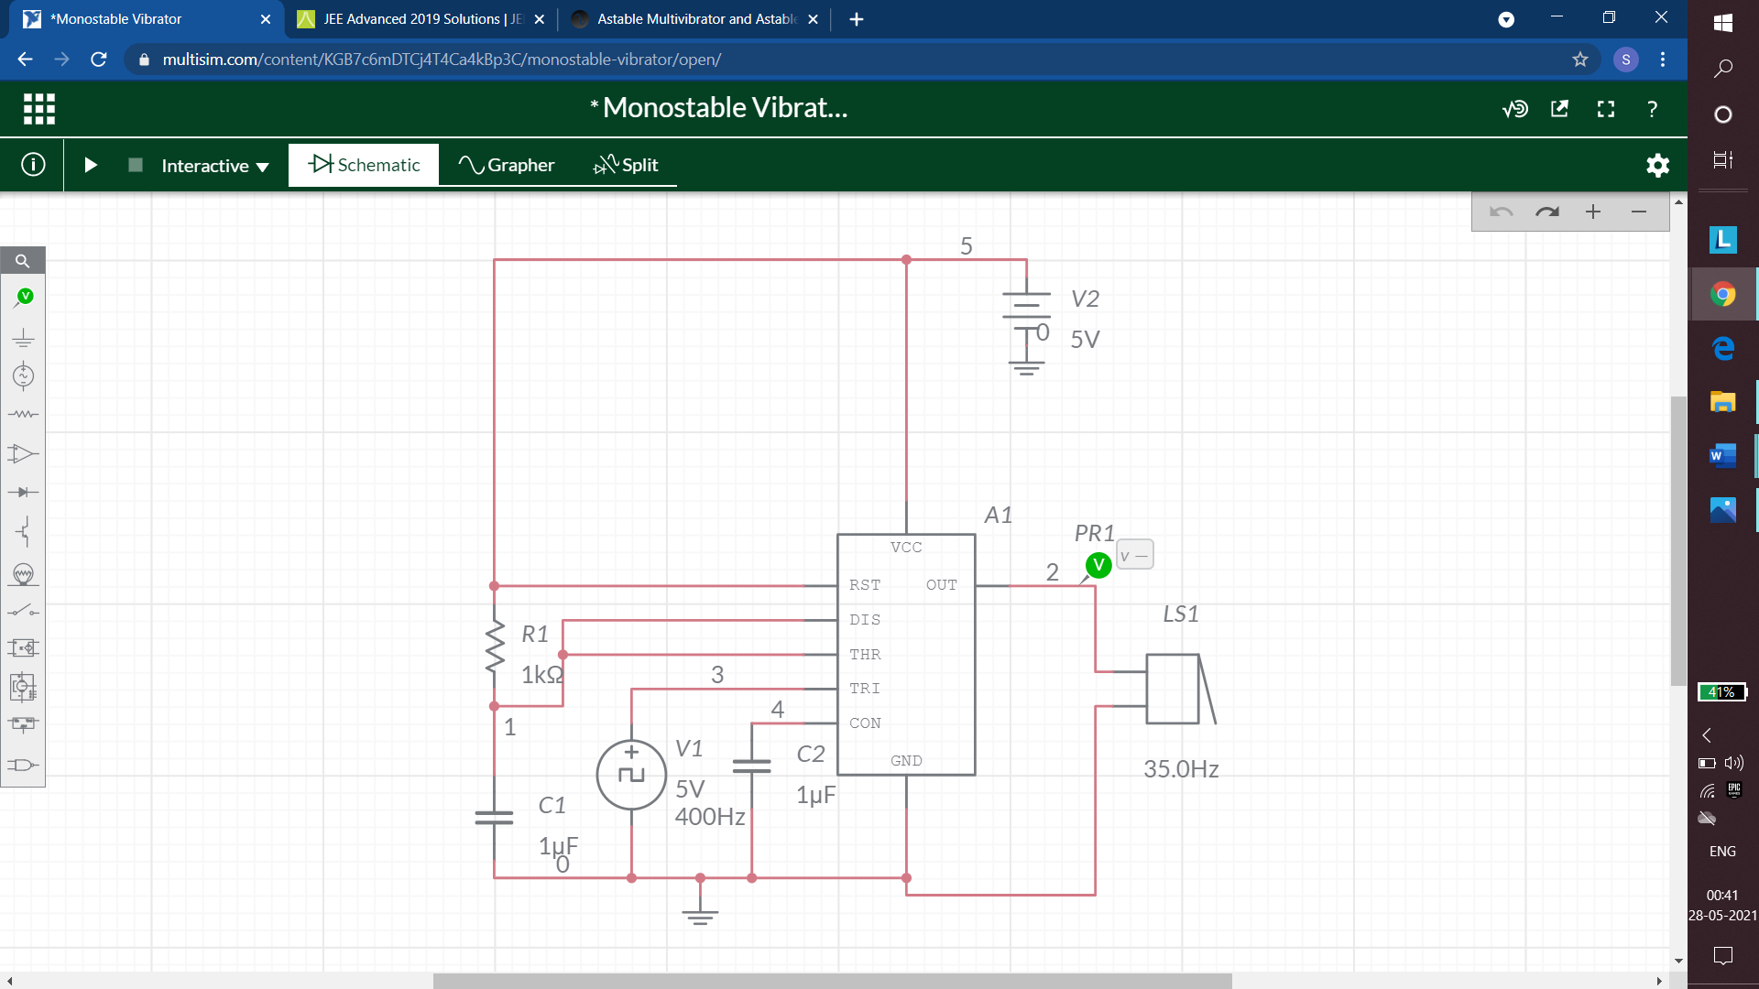

## QUESTIONS

1. How is an Astable multivibrator connected into a pulse position modulator?
2. Explain the function of reset?
3. Derive the expression of time delay of a monostable multivibrator?
4. Which among the following can be used to detect the missing heart beat? a) Monostable multivibrator, b) Astable multivibrator, c) Schmitt trigger, d) None of the mentioned
5. The output waveform of a 555 timer is always a) sinusoidal b) triangular c) rectangular d) square.
6. A multivibrator circuit having one stable state and other quasi-stable state is known as a) monostable multivibrator b) bistable multivibrator c) astable multivibrator d) free-running multivibrator.

# EXPERIMENT 12

## AIM

To design aa Analog to Digital Converter

## APPARATUS REQUIRED

Multisim Software

## THEORY

Analogue to Digital Converter, or ADC, is a data converter which allows digital circuits to interface with the real world by encoding an analogue signal into a binary code. ADCs follow a sequence when converting analogue signals to digital. They first sample the signal, then quantify it to determine the resolution of the signal, and finally set binary values and send it to the system to read the digital signal. Two important aspects of the ADC are its sampling rate and resolution. This digital representation can then be processed, manipulated, computed, transmitted or stored. An ADC carries out two processes, sampling and quantization. The ADC represents an analog signal, which has infinite resolution, as a digital code that has finite resolution. The ADC produces 2N digital values where N represents the number of binary output bits. The analog input signal will fall between the quantization levels because the converter has finite resolution resulting in an inherent uncertainty or quantization error. That error determines the maximum dynamic range of the converter.

## CIRCUIT

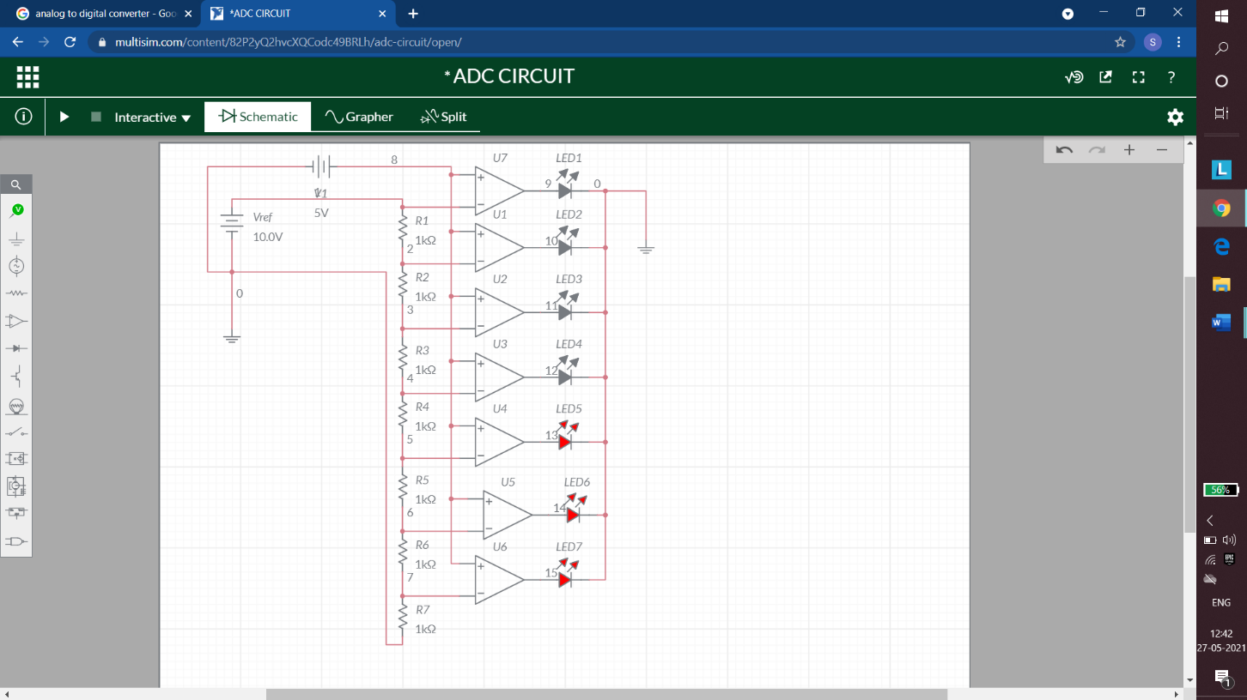

## RESULT

The Analogue to Digital Converter is designed.

# EXPERIMENT 13

## AIM

Digital to Analog Converter

## MATERIAL REQUIRED

Multisim

## THEORY

Digital to Analog Converter (DAC) is a device that transforms digital data into an analog signal. According to the Nyquist-Shannon sampling theorem, any sampled data can be reconstructed perfectly with bandwidth and Nyquist criteria.

A DAC can reconstruct sampled data into an analog signal with precision. The digital data may be produced from a microprocessor, Application Specific Integrated Circuit (ASIC), or [Field Programmable Gate Array (FPGA)](https://www.elprocus.com/fpga-architecture-and-applications/), but ultimately the data requires the conversion to an analog signal in order to interact with the real world. The R-2R ladder DAC constructed as a binary-weighted DAC that uses a repeating cascaded structure of resistor values R and 2R. This improves the precision due to the relative ease of producing equal valued-matched resistors (or current sources).

## CIRCUIT

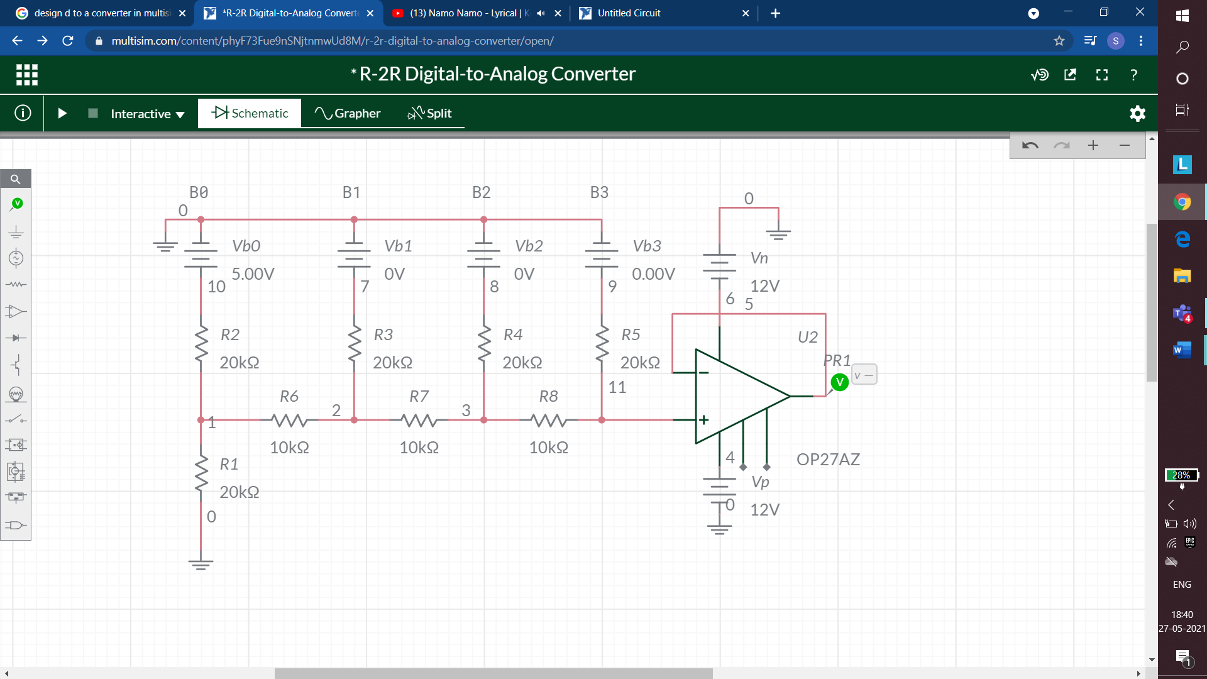

## RESULT

This is R-2R Digital to Analogue Converter.